Report Requirements

Who: How old are you?

* 18: 0%
* 19: 0%
* 20: 41.7%
* 21: 50%
* 22: 8.3%

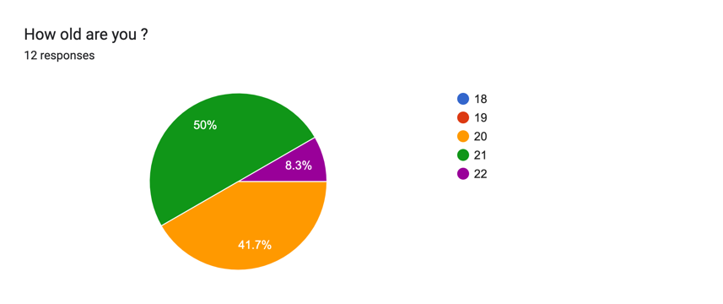

What gender are you?

* Male: 83.3%
* Female: 16.7%
* Other: 0%

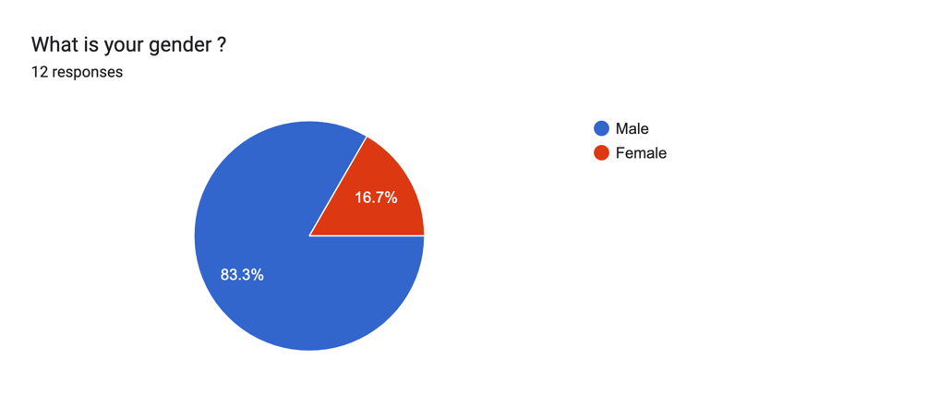

What year are you?

* Freshmen: 0%
* Sophomore: 0%
* Junior: 66.7%
* Senior: 33.3%

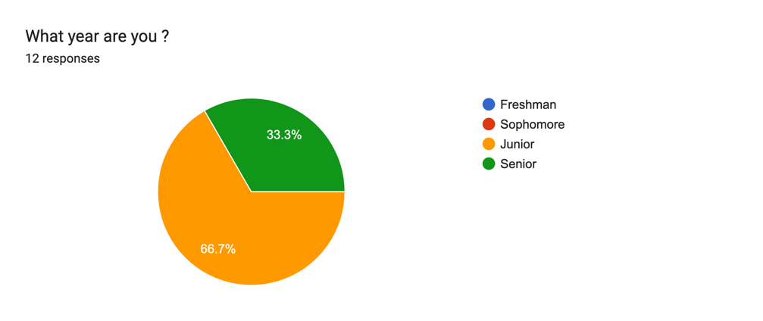

What:

How often you work out?

* 1 time per week: 8.3%
* 2 times per week: 16.7%
* 3 times per week: 16.7%
* 4 times per week: 25%
* 5 times per week: 0%
* 5+ times per week: 33.3%

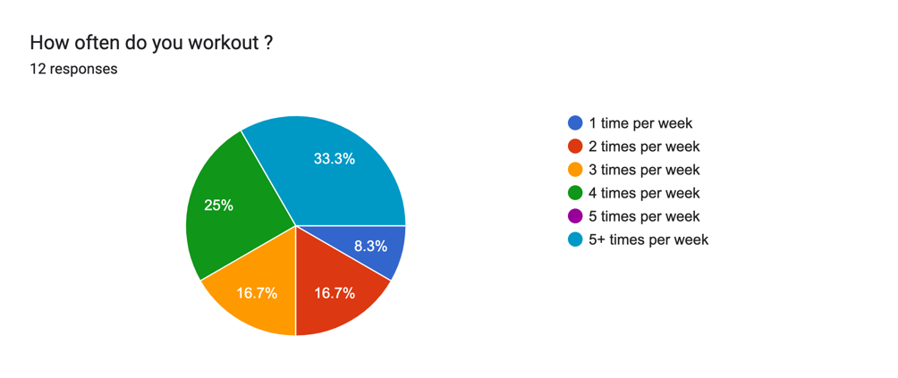

When:

What time of day do you work out?

* Morning: 25%
* Afternoon: 66.7%
* Evening: 0%
* Night: 8.3%

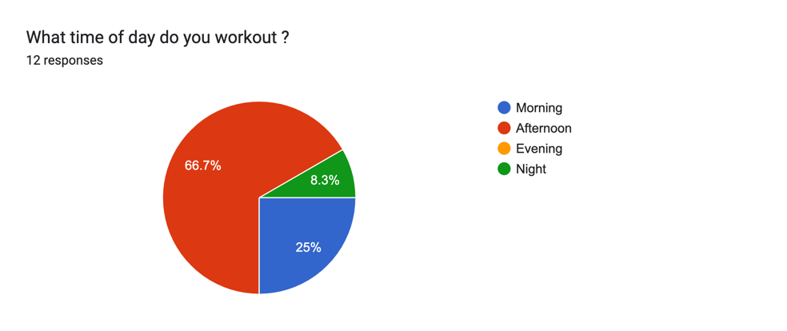

Where:

Where do you work out?

* Cage: 58.3%
* Planet Fitness: 8.3%
* Outside: 16.7%
* Local gym: 8.3%
* My room: 8.3%

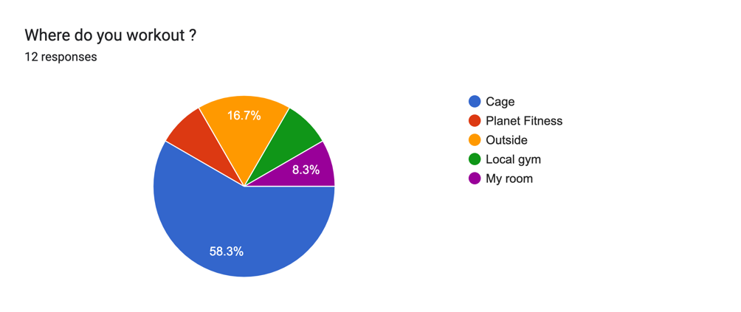

Why:

Why do you work out?

* To look good: 0%
* To feel good: 33.3%
* To be healthy: 58.3%
* To socialize: 8.3%

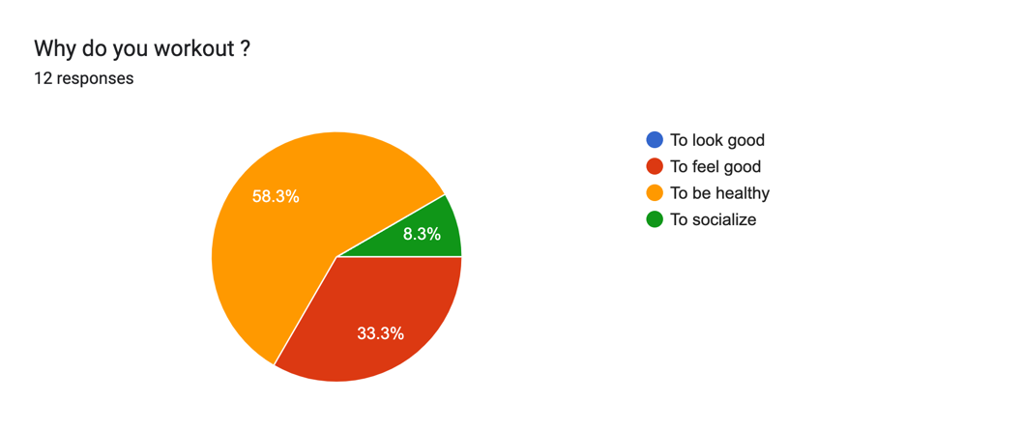

Why do you work out that many times?

* To stay in shape: 50%
* To distract yourself: 8.3%
* To live a healthy lifestyle: 41.7%

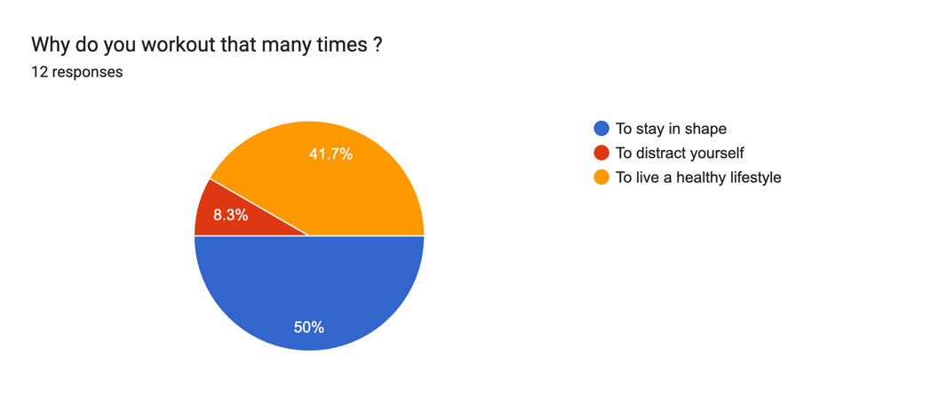

Why do you work out where you do?

* It’s the most convenient: 66.75%
* They have good equipment: 16.7%
* People I know work out there: 8.3%
* Comfortable environment: 8.3%

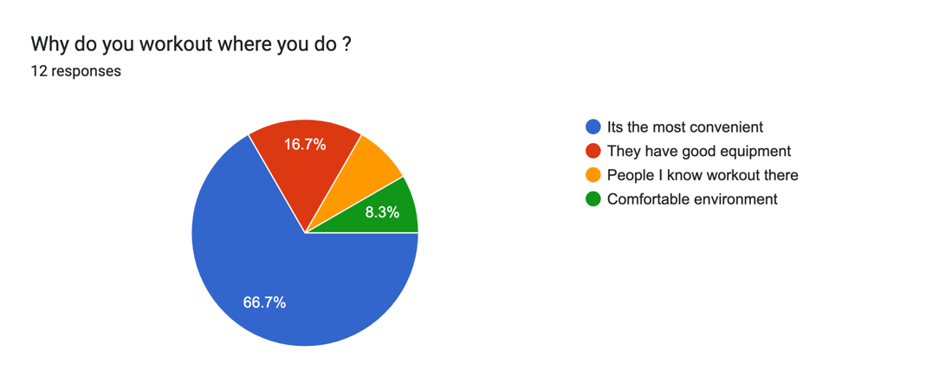

How:

* The method I used to get data for my survey was to email the link of my survey to people I knew. We were given a week and a half to complete the mini project. I used Google forms to create the survey and python to obtain the results from the data.
* Possible weaknesses in my data were that some of the options for answers didn’t fully capture all the possibilities. My study could be improved by providing more detailed questions and more options for people to choose from.

Discussion/Conclusion:

A pattern I noticed was that majority of people prefer to workout at cage and in the afternoon. Which would make sense because that’s the busiest time of day.